Dear all,

During the meeting on Global Lims project (Tuesday 18th October) we have identified Rahul and Shailender to be the points of contact for AWS cloud hosting/infrastructure.

Rahul has already been discussing the hosting of this application with Contact software. The conclusion was that hosting would be done by Apollo.

The development of the software for Global Lims by Contact software is now in a stage that they need at least a test environment in AWS cloud to install their product to enable Apollo key users to get to learn the system.

In this meeting I would like to join Rahul and Shailender with the technical team from Contact software in order to define the setup of this test environment in AWS cloud of Apollo.

I have added Fabien and Nitesh in the invite. I don’t know if (both) of you need to attend but I would like to ask you to forward my invite to the technical colleagues within Contact that can support us.

For your information I have added a design document which was shared by Contact in an earlier stage. Shailender is already familiar with the document.

I want to ask Contact, if you have any additional information available on how to setup the cloud hosting and even better cloud hosting by AWS, please share the information with us BEFORE this meeting.

Please share it via e-mail because Rahul and Shailender do not (yet) have access to our project portal in Aloha.

Goal of the meeting would be to define at least the setup of this test environment, so Rahul or Shailender can create the correct environment in our AWS.

To be able to access our AWS cloud, Contact will require vpn access. I will share the forms to request this access in a separate email.

Best regards,

Patrick Goossens

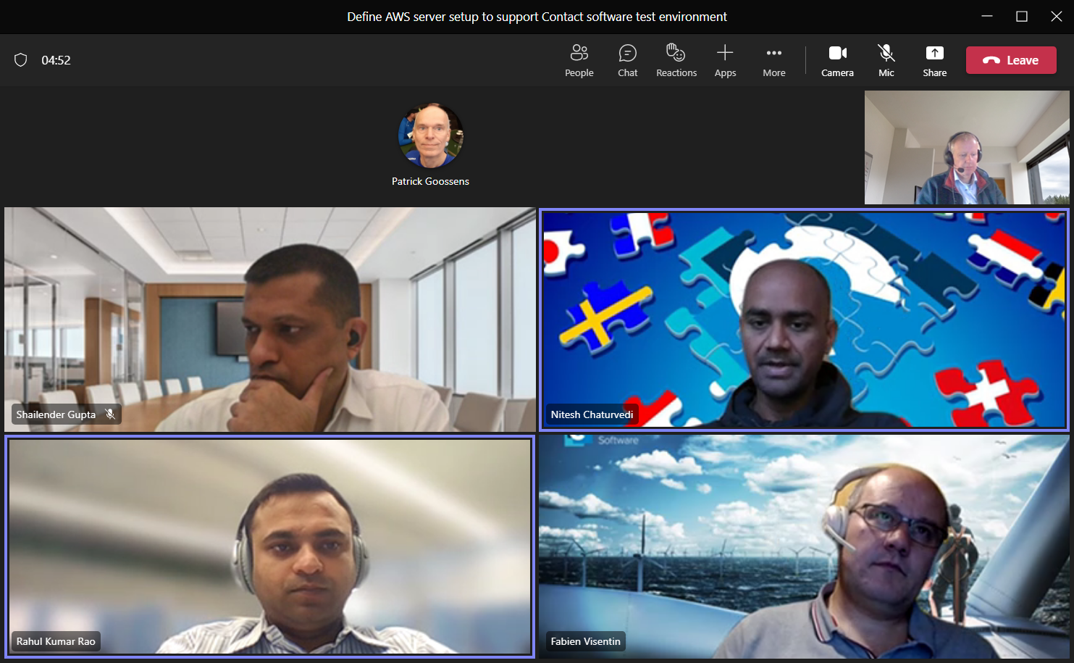

SAP-PO wordt naar AWS-cloud gebracht.

Er waren 2 opties, er is gekozen voor AWS-installatie van Apollo te gaan.

Voor app-layer we need containers, voor horizontale scalability. Apache op Linux.

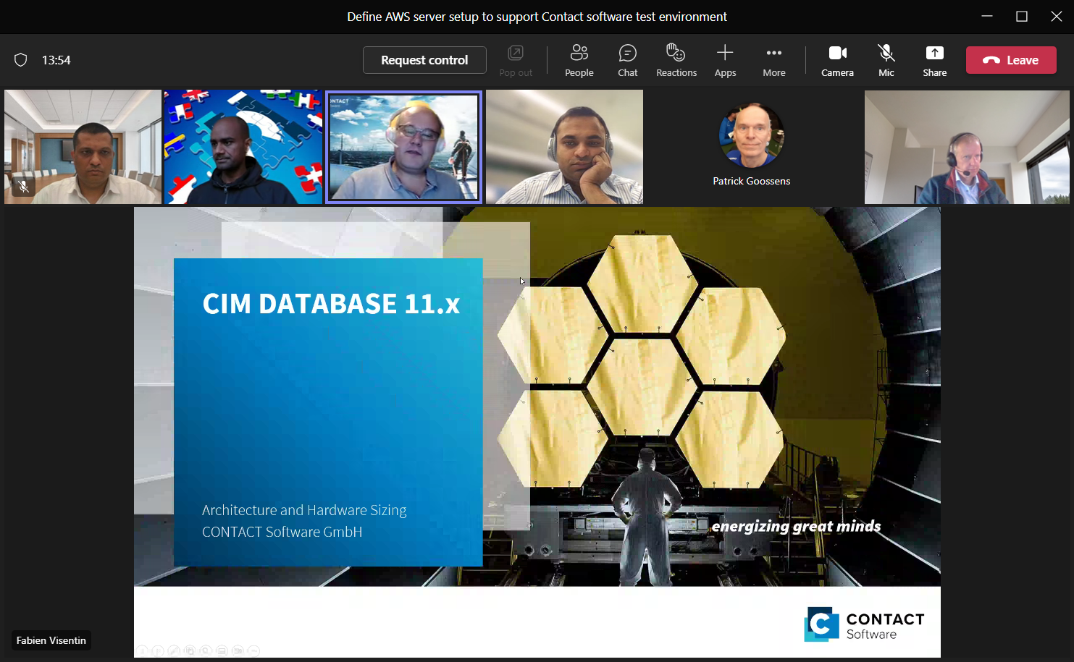

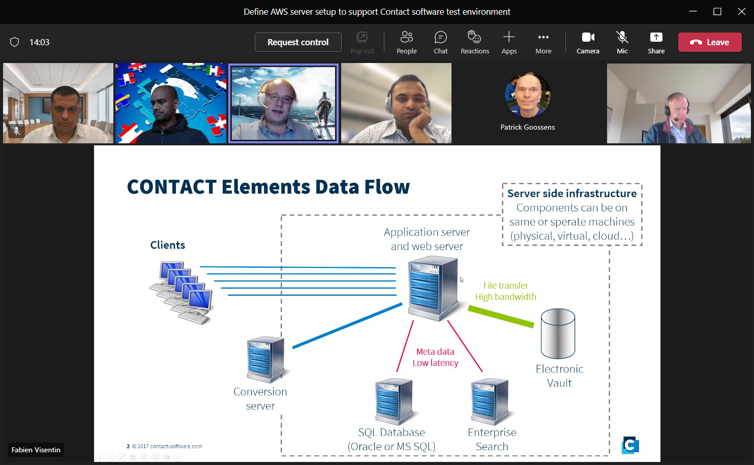

ELECTONIC-VAULT=FILESERVER

1 VPC, and 1 subnet. LIMS in apart subnet.

30 users for test-environment.

Om mee te beginnen.

Very heavy,

1e plant CHENNAI R&D.

Conversion-server wordt op ON-PREMISE gestart !!!

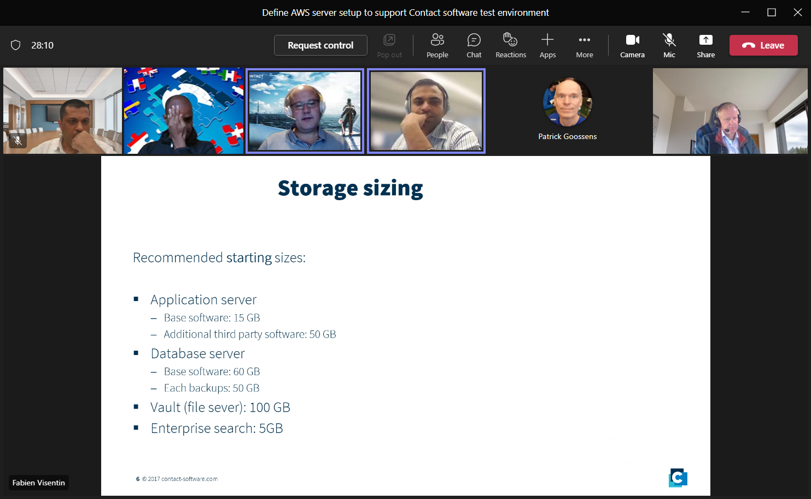

Hebben we een aparte file-server nodig? Ja. Geen S3. Alleen file-system.

Hopelijk in de toekomst wel !!!

Wel moeilijk en zelf te beheren.

Database-server op RDS, die hebben we hier dus niet nodig.

Geen combinatie linux=windows.

Oracle-standard-edition. Use SUSE linux.

Security-issues

Interfaces, etc.

Availibity

HAM-documents moeten vandaag teruggestuurd worden.